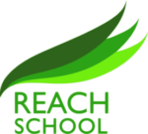

English
Reading expands minds, knowledge, and opportunities

The English language is an ever-evolving piece of art that can open doors
- Our aim is to ensure that all learners have experienced a wide range of high-quality reading material
- To promote reading, writing and high-quality literature
- To devise an English curriculum which is sequenced to develop the acquisition of knowledge and skills.
- To empower students with a wide vocabulary

At REACH the aim is to enrich students through a range of fiction and non-fiction texts which inspire learners and enable them to learn about the world around us. We aim to meet the needs of a rapidly changing world through personalised learning.
In Year 11, students receive 4 lessons a week: two language lessons and two for literature. More time is given to English on the timetable as it supports and underpins the curriculum. In Year 10, students receive three lessons to embed key language skills and introduce them to English literature.
Literature helps students learn about historical events and life for those from different eras, societies, and religions. Thusly, students are able to understand the impact that history has had on the society today and help broaden their understanding of the world today and how things have developed over time.
Fiction unlocks student creativity and they are introduced to worlds and characters that are new and intriguing. At times, they read about scenarios that they can identify with and realise that they aren’t alone.
Non-fiction opens their minds to current affairs and gives us the opportunity to discuss any issues that concern them and dispel misconception from fake news. Learners are able to question and debate their ideas on topics.
English is empowering, as students develop a rich vocabulary making them better equipped to articulate what they truly want to say, whilst understanding the power of words.
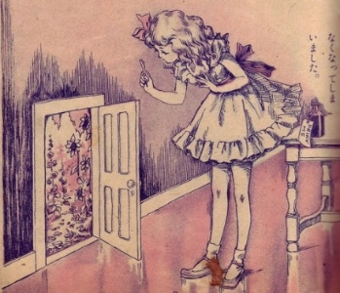
The skills they learn in English will help develop their reading and writing skills, but more importantly, make them better communicators – a skill for life!

