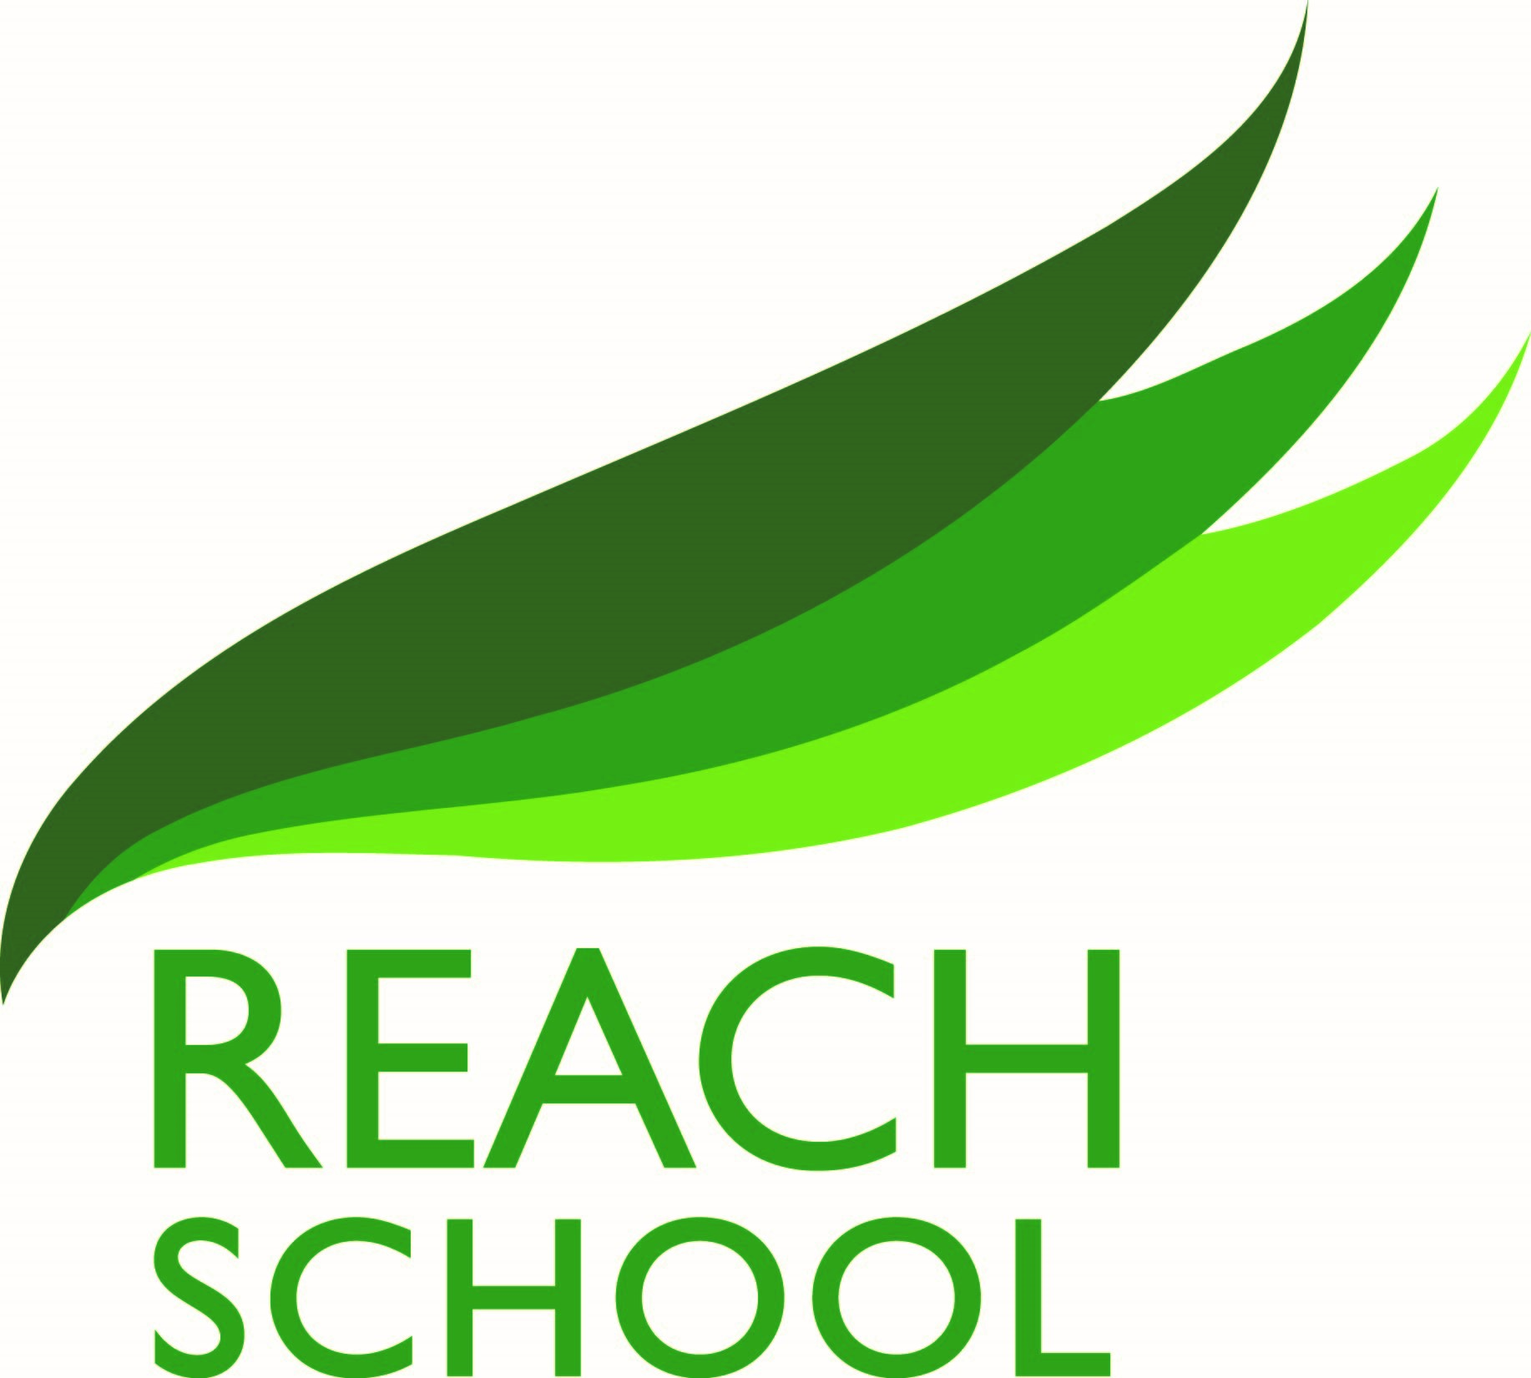
Curriculum Statement
At REACH school, we understand the importance of a well-rounded, broad and fulfilling curriculum to prepare our students for their further education, and for their future as citizens of the UK.
At REACH School, we recognise that students who attend our school exhibit a wide range of both educational and emotional needs, which by their very nature can impinge negatively on their progress. Our aim is to provide them with the highest quality provision. It is therefore important that we provide a curriculum which is enriched by a range of planned activities and experiences to enhance learning and personal development so:
- Students become successful learners, who enjoy learning, make progress and achieve.
- Students become confident individuals who are able to live a safe, healthy and fulfilling life.
- Students become active and responsible citizens who make a positive contribution.
Our curriculum needs to be flexible, inclusive and offer continuity, coherence and progression, motivating and challenging all of our students, whatever their ability, and promoting achievement for all.
Our curriculum seeks to promote the following values:
- Education as an important and on-going process, which enriches the lives of all members of the community and through this, the society in which they live and to which they contribute.
- Education as a route to the spiritual, moral, social, cultural, physical and mental development, and thus the well-being, of the individual.
- Education as a route to equality of opportunity for all.
- Education should also reaffirm our commitment to the virtues of truth, honesty, tolerance, trust and respect.
Reaching all Educating to Achieve through Challenge and High Expectations

Life Skills

Life Skills at REACH School is the way in which we deliver PSHE. Through work in lesson time and a wide range of activities across and beyond the curriculum, students gain practical knowledge and skills to help them live healthily and deal with the spiritual, moral, social and cultural issues they face as they approach adulthood.
Subject overview- all students have the opportunity to study:
- GCSE English, English Literature, GCSE Mathematics, GCSE Science
- Life Skills
- Two more GCSE options from Art, Hospitality and Catering, Physical Education, Media Studies and History
- Functional Skills in Maths
- AQA Unit Awards

Enriched curriculum

In Year 10, Work Related Learning uses the context of work to develop knowledge, skills and understanding that are needed in a working environment. Students attend their work placement on a weekly basis for 5 hours where they gain employability skills, skills in punctuality, customer service, tool handling, communication, team-work and ICT, alongside level 1 or 2 vocational qualifications.
- In Year 11, Pathways provides the opportunity for students to reflect on their own skills and attributes, and to focus on developing and applying employability skills in their future careers. All Year 11s have a one to one careers interview with Birmingham Careers Service and have a bespoke careers action plan created to widen Post 16 aspirations and support students on their journey.
- Active Citizenship helps all student to develop a positive and resilient identity through experiential learning. Active Citizenship helps students to develop an understanding of being part of something bigger than themselves and the curriculum will give opportunities to feel an active part of the school, the local area and the wider community. The curriculum will give students the opportunities to develop character qualities through both classroom teaching and outdoor opportunities.
- CEIAG is an integral part of our development plan, ensuring all students have access to support and opportunities to enable them to make informed decisions about their future. The Gatsby Benchmarks provide a clear framework to help us to develop our careers provision across all areas of the curriculum. We work closely with Birmingham Careers Service and Birmingham Careers Hub to ensure that students have a pertinent and aspirational Post-16 placement. This year we are working in partnership with Birmingham Careers Hub, implementing the ‘Me and My’ Project, with the intention that intensive engagement in career development activities at a younger age increase the students’ chances of attaining minimum GCSE requirements to put them on a pathway to positive employment and a better future.
- RSE is a significant part of the curriculum at REACH and teaches our students the importance of positive and loving relationships, family life and respect for all others, diversity and equality in all its forms. Our RSHE curriculum empowers our students to develop and form their own positive values, attitudes, personal and social skills, and increase their knowledge and understanding of how to make informed decisions and life choices.
- Mental Health and Wellbeing Many of our students start REACH having been disengaged from learning with the vast majority having Social, Emotional or Mental Health issues, so supporting our students in recognising and managing these areas is a priority. At REACH School we understand the importance of supporting our students’ mental health and physical wellbeing through curricular and extra-curricular activities such as the gym, Life Skills, Pathways and our Active Citizenship, where students investigate their emotions and develop coping strategies. We work with our students through targeted literacy and emotional literacy interventions to not only improve our students ability, but to help them develop their own social/emotional resilience so that they are better equipped for future pathways.

