History
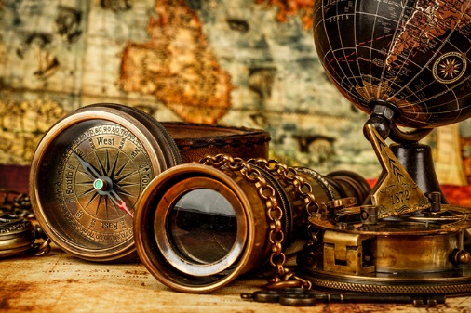

Those who do not learn from history are condemned to repeat it.
At REACH school we believe in the importance of not just learning history but learning from history. The study of History equips pupils with the ability to critically analyse source material, assess the merits of different arguments, hone their listening and debating skills and recognise bias and propaganda. The skills they will learn from studying History will help them to critically evaluate the information they access and to be able to form a well-reasoned and considered opinion. This is crucial in an era of fake news, where news is updated 24 hours a day, where information is gleaned from main stream media platform or YouTube: where most of our students gain their news and information from (student voice survey September2021).
History promotes excellent communication, literacy and writing skills, essential for reducing the vocabulary gap and improving the reading ages of our students and improving their life chances. Reading academic literature, engaging with primary sources and taking trips to historic sites boost the cultural capital of our students.
Through addressing overarching questions which reflect on what it is to be British and British values, students are promoted to have high self-efficacy and a reflective attitude. This allows them to confidently express themselves in the world of work or when they progress to further education. History offers many academic and aspirational career paths such as journalism, law, business, politics, marketing and teaching.
Birmingham is a multicultural city and REACH school is a microcosm of this. Understanding past events and people and their significance gives students a better insight into the world around them, and to have a greater understanding of themselves and their place in their city and communities. At REACH we understand the need to educate our students for effective membership and leadership in global, social and economic communities by providing a historical context of culture, power and democracy.

