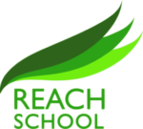

Pathways
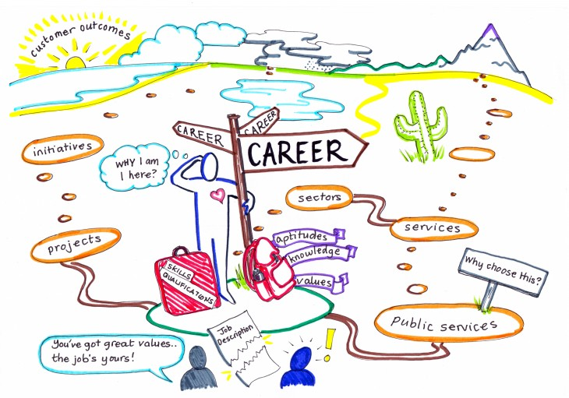
The best way to predict the future is to create it – Abraham Lincoln
Pathways is a bespoke and personalised opportunity, to enable students to prepare for post 16. The skills learned from studying Pathways will help students to plan for their future career and build knowledge and experience, enabling them to encounter and access the pertinent Further Education and Job training. Students will receive personal guidance, learn from the career and labour market information, and experience meaningful encounters with employers and further and higher education establishments.

Each student sets up a Start Profile which enables them to explore their skills and matches careers to their interests. This programme can be accessed anywhere, and students can adapt their profiles at any point in order to help them make informed career choices.

They also learn ICT skills which are important to help them in their next steps, be it an apprenticeship, Further Education, or a work placement.

Students are also given the opportunity to learn basic budgeting skills, understand how wages work and how to open a bank account.

We aim for our students to leave REACH feeling confident in basic skills needed for adulthood and ensure they follow the path that it right for them.

