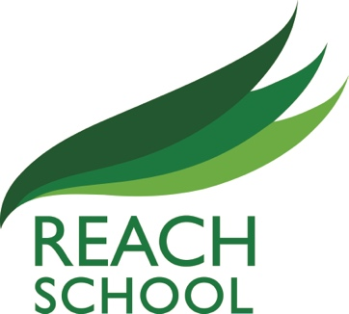

Reach School Governors meetings 2021 – 2022

Full Governors
Thursday 23rd September 2021
Thursday 18th November 2021
Thursday 20th January 2022
Thursday 17th March 2022
Thursday 12th May 2022
Thursday 7th July 2022
Finance Committee
Thursday 16th September 2021
Thursday 11th November 2021
Thursday 13th January 2022
Thursday 10th March 2022
Thursday 22nd May 2022
Thursday 30th June 2022

