REACH School

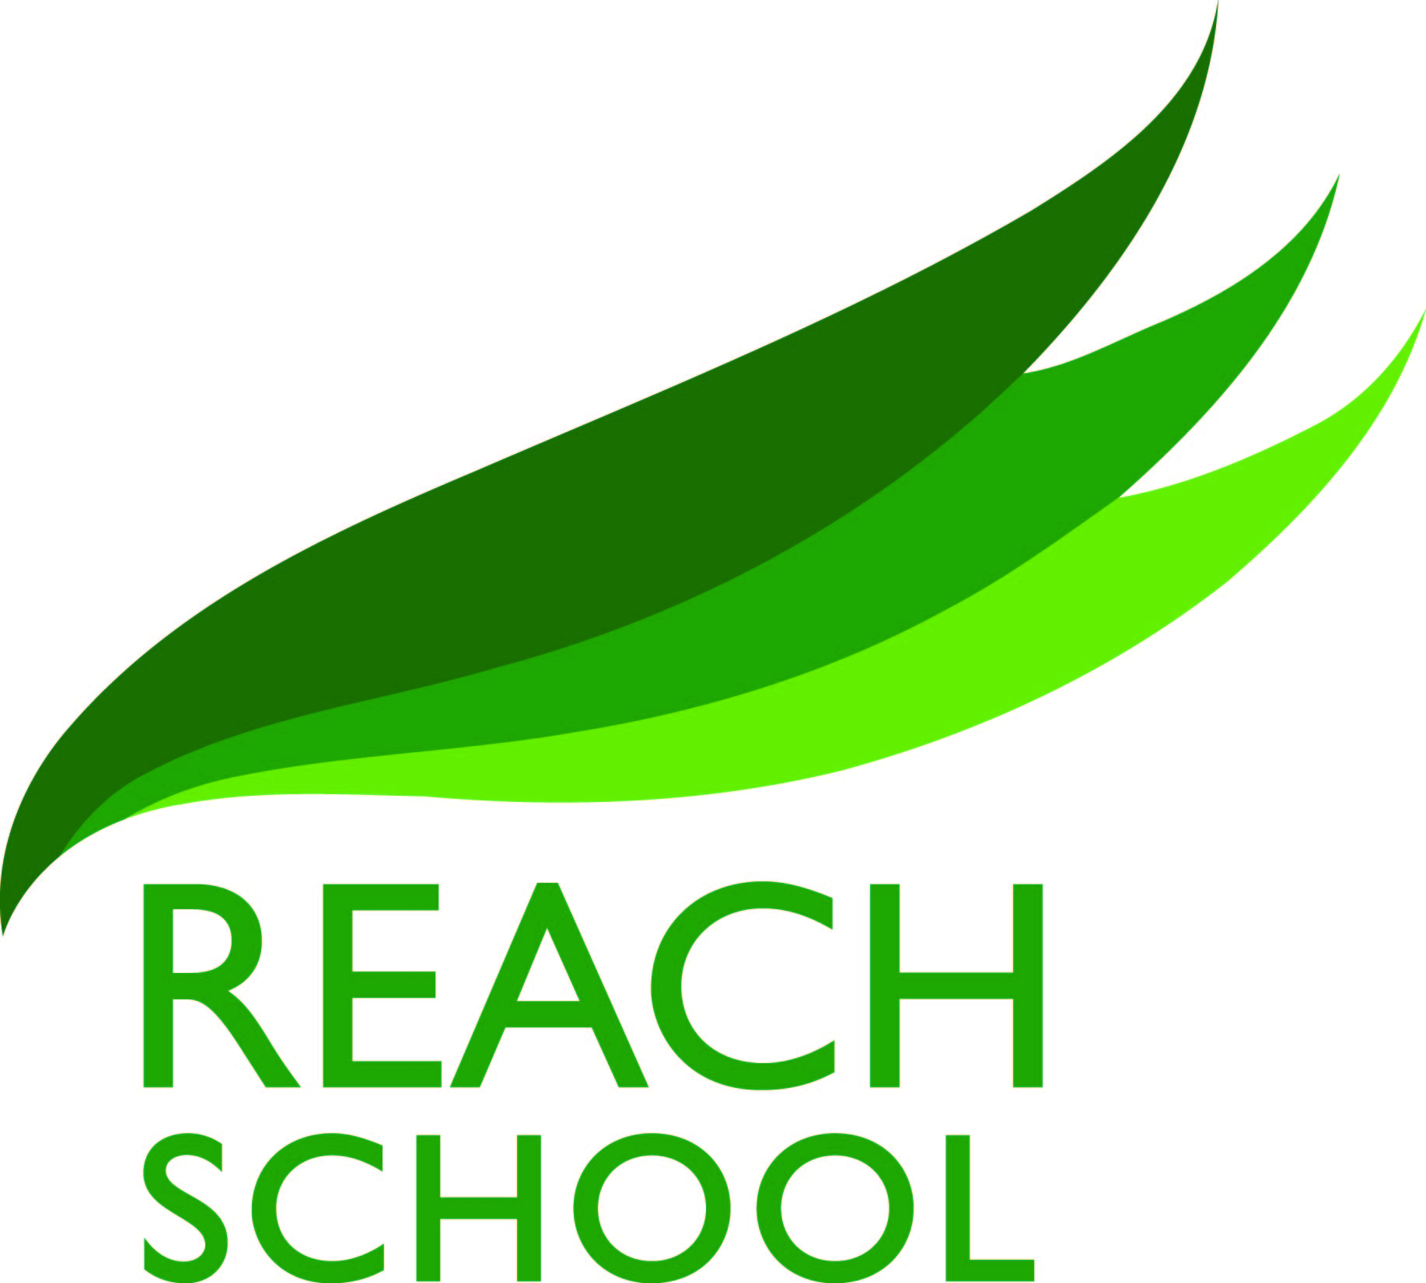

SEND Information Report

Reviewed and upated annually by SENDCo

Date Reviewed September 2021
Date of Next Review September 2022

The Special Educational Needs and Disability Regulations (2014) require each school to publish certain information regarding provision for students with special educational needs and disabilities (SEND). At Reach school we hope parents/carers of current and prospective students find the following information helpful. We encourage all interested parties to contact the school for more information.
Points highlighted in red are additional information added to the School Information Report during the period of Covid-19 and national school closures.
What is SEND and SEND support?
SEND stands for special needs and, or a disability.

The Code of Practice 2015 states that:
‘A child or young person has SEN if they have a learning difficulty or disability which calls for special educational provision to be made for him or her.’

Many children will have special educational needs of some kind during their education. Schools and other organisations can help most children overcome the barriers their difficulties present quickly and easily. A few children will need extra help for some or all of their time in school.

What kind of special educational needs are provided for?
REACH School is an Alternative Provision setting primarily for Key Stage Four students (years 10-11) with some transitional programmes for Key Stage 3 (Year 9) students where able. REACH is committed to being as inclusive as possible, with the needs of SEND learners being met within school wherever possible. Special Educational Needs fall within 4 categories of need:
• Communication and Interaction
• Cognition and learning
• Social, emotional and mental health difficulties
• Sensory and/or physical needs
A student may have needs that fall into one or more of the above categories. Where a students is identified as having SEND, REACH will seek to remove barriers to learning and put SEND provision in place.

Birmingham’s Local Offer
Within Birmingham there is much information about types of Special Educational Needs and Disabilities and services and provision available for those with additional needs. You can find information about what is available in Derby at https://www.localofferbirmingham.co.uk.

What policies for SEND are available?
SEND Policy (2021-2022) is currently available. Other school policies available that relate to SEND include Teaching and Learning, Behaviour, Medical Conditions, Safeguarding, Equal Opportunities and the school accessibility plan. This report is written in compliance with the SEND Code of Practice (2015) and section 69 (2) of the Children and Families Act (2014).

How does the school know if children need extra help?
Identification
The emphasis at REACH School is on the early identification of learning difficulties and educational needs, thus permitting prompt assessment and appropriate provision.
The SENCo considers:
- Pre-transfer information from previous schools, including about students with statements/EHCPs
- Concerns expressed by subject teachers and/or Behaviour and Learning Practitioners
- Parental concerns
- Monitoring of student progress and engagement
- Cognitive Ability Tests (spelling and reading) on entry and potential for Access Arrangements identified as part of the exams process.

The progress of all students is monitored regularly by subject teachers and the senior leadership team by data analysis and pupil progress meetings, so that when a pupil is not making expected progress in a particular area of learning the school can quickly identify the need for additional support. When deciding whether to make special educational provision for a young person, a meeting will be arranged between the SENDCo, subject/class teachers, and the Pastoral Director to consider all the information gathered from within the school.

This will be discussed with parents/carers and the pupil concerned highlighting areas of strength or difficulty, planned additional support the student may need and discuss any referrals to outside professionals to support the young person’s learning.

Where a young person is identified as having SEND, the school will seek to remove barriers to learning and put SEND provision in place. In accordance with the SEND Code of Practice (2015), SEND support will take the form of a four part cycle called the Graduated Response:

Assess - The student will be assessed thoroughly to identify the key area of need and ‘next steps’ targets will be produced
Plan - Provision needed to support the student to achieve their ‘next steps targets will be carefully planned to scaffold the students learning towards their goal. This may be in the form of: intervention; curriculum adaptations; resourcing and additional support. If the support is through intervention (individual or small group work over and above what is offered in class), this is delivered by skilled teachers/support staff.
Do - The support planned is put in place and monitored over a period of time leading to review.
Review - Following the additional support, it will be reviewed against the student’s targets in order to consider next steps. Where additional or specialist support is provided targets are set and regularly reviewed by the SENDCO and people involved in the delivery of support.

We aim to work with the young person and parents through this process.

What should I do if I think my child/young person may have special educational needs?
If parents/carers have concerns about the progress or attainment of their child they should in the first instance make an appointment to speak to their child’s personal tutor to discuss their concerns, who will then liaise with our Special Needs and/or Disabilities Coordinator (SENDCo) appropriate.

What are the different types of support available at our school?
Teachers and our Pastoral Team have the highest possible expectations for your child and all young people in their group. The quality of teaching and learning is reviewed regularly to ensure the highest possible standards are achieved. The school has a training plan for all staff to improve the teaching and learning of young people, including those with SEND. This includes whole school training on SEND issues, Mental Health and Trauma Informed and Attachment Awareness (TIAAS).

REACH aims to teach all students together in smaller groups where possible, with the subject teacher differentiating and supporting the student. Group sizes are no bigger than 8 students in a class. Additional adults are often present in the teaching rooms to support the learning and/ or additional needs. At times it may be necessary for a student with SEND to assess intervention; either as part of a group or 1:1 with targeted interventions. These are strategies which may be suggested by the SENDCO or other professionals working with your child to support learning and engagement.

For some students the school uses outside support agency resources and staff with parental agreement. REACH provides a range of support and interventions which may be used when we identify a need for additional support. We will regularly monitor the progress of all students receiving additional support to ensure that the provision we have put in place is having the impact we are expecting.

Targeted support:
Where appropriate, students may receive additional support to target specific needs such as literacy, handwriting development, reading, numeracy, and social, emotional and mental health/wellbeing:

Area of need | Communication and Integration | Cognition and Learning | Social emotional and Mental Health | Sensory and/or physical needs
R  e  s  p  o  n  s  e  s | - Flexible teaching arrangements  - Help in literacy skills  - Help in acquiring language  - Help in articulation  - Help in organising written language  - Help in alternative forms of communication  - Use of ICT | - Flexible teaching arrangements  - Help in literacy skills  - Help in pronouncing language  - Help in sequencing and organisational skills  - Help in organising written language  - Help in problem solving and developing concept  - Additional learning materials | - Flexible teaching arrangements  - Help in adjustment to academy routine  - Help in development of social skills  - Help in acquiring positive integration skills  - School systems which control difficult behaviour and encourage positive behaviour  - Creative/artistic interventions | - Flexible teaching arrangements  - Appropriate seating and lighting  - Adaptation to physical environment  - Alternative forms of communication  - Specialised aids and equipment  - Modified learning materials

There are many more that may be put in place depending on the individual pupils needs.

What emotional, mental and social support is available for students with SEND?
Pastoral mentoring, counselling services, family support work and links with external agencies are all provided to ensure that social, emotional and mental health needs of our SEND students are met. We also offer creative/artistic interventions to assist students in understanding their own emotions and self-regulation strategies.

What adaptions may be made to the curriculum or the learning environment to support children with SEND?
Adaptations to curriculum or learning environment may be made to remove barriers to learning. Things such as:

- A calm, routine and safe environment
- Seating arrangements in the classroom
- The temperature of the classroom
- Using enlarged resources
- Use of ICT including reading aides
- Leaving lessons early
- Review of progressive timetables
- Use of colour overlays to support students with dyslexic tendencies
- Having someone scribe your work

Most students access the National Curriculum at their broad age appropriate expectations and this is differentiated in our small teaching groups to enable this to be successful.

How is the decision made about what type and how much support my child will receive?
Quality First Inclusive Practice is the high standard of differentiated quality teaching that we expect all staff to deliver at REACH School. Parents are contacted when concerns arise, or additional support groups or individual intervention takes place; a discussion is held as to what provision the school will be making. If a student needs to be referred to an outside agency, parents will be asked for their permission and views which form part of referral process. All interventions are monitored for impact and outcomes are defined at the start of any intervention. The SENDCO oversees all additional support and regularly shares updates with Governing Body.

How will my child’s progress be monitored?
Student progress is continually monitored by subject teachers, Senior Leadership Team, Pastoral, as well as the SENDCo. Progress is reviewed at regular intervals throughout the academic year and weekly teaching and learning meetings.
If your child is requires SEND support or has an EHC Plan, you will receive regular formal reports on their progress as well as having the opportunity to speak to subject teachers. The SENDCO will also monitor that the young person is making good progress in any targeted work while also monitoring the effectiveness of the provision or interventions.
The progress of young person with an EHC Plan is formally reviewed at an annual review.

During a period of enforced closure (for example, Covid-19) the SENDCO will work with the Local Authority to decide when and how to hold Annual Reviews. These may be completed over the phone or by video call, as appropriate. The SENDCO will consult the student on their views as well as the parent and will ensure these are reflected in the Annual Review process.

How will school keep me informed of my child’s progress? / How will school help me to support my child’s learning?
Termly parent review days and reports give all parents and carers regular feedback on their child’s progress. If your child receives regular extra support you will receive additional feedback on their progress. When appropriate, parents and carers may be contacted mid-term to discuss the support that the school are providing and advice will also be given on how they can help their child at home. Pupil’s views will be obtained and they will be asked to join the meetings. We work in partnership with parents to support each young person’s wellbeing, learning needs, progress and aspirations. Teachers are available to meet with parents before or after school if needed. Parents can also contact the school for an appointment with the SENDCO.

When following the government’s national guidance around social distancing parents of SEND students may decide to educate their child at home to ensure their safety. This decision will be made in partnership with the Headteacher and SENDCO. Parents of SEND children will be contacted weekly by a member of the SEND or pastoral team who will help with: concerns around accessing work; speak to the student to check on their wellbeing; make expectations about completion of work clear to both the student and parent; liaise with teaching staff around the need for further support, where appropriate.

How will school involve other professionals? You may be asked to give permission for your child to be referred to a specialist professional, e.g. Educational Psychologist. This will help the school and you to understand your child’s needs better and so support them more effectively. All external partners we work with are vetted in terms of safeguarding and when buying in additional services we monitor the impact of any intervention against cost, to ensure a value for money service.

The specialist professional may work directly with you and your child and may make recommendations on support strategies to be used at home and in school. Professionals working with REACH will include representatives from Communication and Autism Team, Pupil School Support, Counselling services, Speech and Language and School Nursing Team.

Where appropriate, external agencies will be deployed to work remotely with students to ensure that ongoing casework and assessments can take place with as little delay and disruption as possible. These sessions may be held over the phone or via online platforms. Some video sessions will be completed when the appropriate consent has been gained by parents.
We recognise that during the period of Covid-19 student’s social and emotional development and wellbeing could be adversely affected. As a result, we will provide access to resources that explain Covid-19 in a child-friendly manner. We will direct external agencies for wellbeing to provide support for students who may be identified as needing additional support. We will ensure each SEND student is contacted weekly to check on their progress and wellbeing. We will provide links to online mental health provision on the school website that all students and parents can access and ensure they are appropriately signposted.

What training have the staff had supporting children with SEND had?
The school has a development plan, identifying training needs for all staff to improve teaching and learning of all students including those with SEND. This may include whole staff training on SEND issues or to support identified groups of learners in school, such as ASD or dyslexia. Whole staff training will be to disseminate knowledge, strategies and experience and to ensure consistency of the schools approach for children with an SEND. Individual teachers and support staff attend training courses run by outside agencies that are relevant to the needs of specific students in School. We regularly invest time and money in training our staff. All of our teachers hold qualified teacher status and training is given regularly to all staff on specific learning needs.
The SENDCO attends regular meetings organised by the Local Authority and South Network of Schools. The SENDCO is currently undertaking the National SENCO Award and has recently completed a Post-Graduate Diploma in Integrative Psychotherapeutic Counselling and a Post-Graduate Certificate in Education.

Where possible and within reason, staff will continue CPD through online courses and training.

How will school prepare and support my child to join the school?
We have an Induction programme in place for welcoming all learning into our setting. This includes baseline testing in Reading, Spelling, English and Mathematics so we can group and identify support for students accordingly. Pastoral and SEND mentoring is provided for students as and when needed.

How will my child be able to share their views?
Upon admission at REACH School, students complete a ‘This is Me’ profile, ‘Fresh Start’ and emotional literacy tasks. These provide information about the students likes and dislikes and what they feel helps them learn best. This will enable your child to discuss their views about the academy and any problems they may have. As teachers and staff continue to build relationships and identify needs, these documents are updated to identify further factors that can help the student learn.
We value and celebrate each young person being able to express their views on all aspects of school life. This is usually carried out through regular meetings of the student voice and pastoral/SEN interventions
If your child has a statement/EHC Plan, they will be involved in writing and reviewing their own Outcomes.

How accessible is the school?
Where feasible, we make reasonable adjustments to improve the accessibility of our environment to meet individual needs. Our policy and practice adheres to The Equality Act 2010. The school is accessible to students with physical disability via a lift. We have a disabled toilet on each floor.

Where possible and within reason, teachers will set accessible work for students with SEND when working from home. The SENDCO will be contactable should parents or students need additional support or guidance to complete the work. A member of the SEND team will contact all SEND students weekly to consult with them about access and completion of work.

Transition from Key Stage 4 to Key Stage 5/and liaison with alternative provider:
All students in year 11 receive careers guidance sessions on a regular basis.

This will involve:
Pathways
Active Citizens
Enterprise sessions
Site visit and presentation of enterprise ideas.
CV’s
Application forms

What should I do if I have a complaint regarding my child’s SEND?
We take our responsibilities seriously and work hard to ensure that each child’s special education needs and disabilities are met. However, should a parent have a complaint regarding this, then the school’s complaints procedure should be used, which can be found on the school website.

Named school contacts for SEND:
- SENDCO: Mr Jayson Rawlings (School Mental Health Lead)
- SEND Governor: Sarah McAneny (Student Welfare)

Details of our main linked external providers:
Pupil Support Services: http://accesstoeducation.birmingham.gov.uk/index.php/PSS/welcome-to-the-pupil-and-school-support-service.html
Communication and Autism Team: http://accesstoeducation.birmingham.gov.uk/index.php/CAT/welcome-to-the-communication-and-autism-team.html
Speech and Language: http://wmspeechtherapy.co.uk/
Sensory Support: http://accesstoeducation.birmingham.gov.uk/index.php/SS/welcome-to-sensory-support.html
School nurse: http://www.bhamcommunity.nhs.uk/patients-public/children-and-young-people/services-parent-portal/school-health-services-school-nursing/

To learn more about Birmingham’s local offer for SEND: https://www.localofferbirmingham.co.uk/

Agencies that may be of help to parents:
SENDIASS: Email - SENDIASS@birmingham.gov.uk
Phone- 0121 303 5004 Address- Lancaster Circus, PO Box 16289, Birmingham, B2 2XN Website- http://www.birmingham.gov.uk/sendiass

Forward Thinking Birmingham (Child and Adolescent Mental Health Services): Phone- 0300 300 0099 Website: https://www.forwardthinkingbirmingham.org.uk

