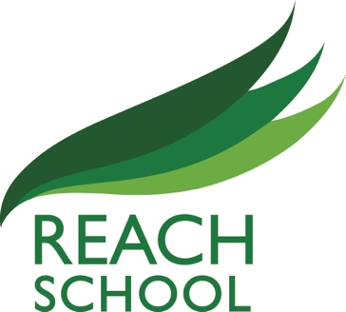
Reaching all Educating to Achieve through Challenge with High Expectations

29th November 2021
Dear prospective applicant
This an opportunity for an outstanding Higher Level Teaching Assistant to join REACH School. This is a Grade 4 post on a full time, term time only contract.
We are looking for someone to join our staff team who is enthusiastic about supporting our students to reach their full potential.
REACH School is an OFSTED ‘Good’ Alternative Provision School that provides education for 64 students in year 9, 10 and 11. Our students are referred to us either through the South Network sharing panel, the local authority or directly via individual schools. The majority of our students have barriers to learning and have been unable to access education in the mainstream, traditional way. We pride ourselves in being the school that is able to re-engage them through our exciting, imaginative curriculum alongside an exceptional pastoral support package.
You will find information about the post and the school in this pack and on our website and hope that as you discover more about us you will choose to make an application. To apply, please complete the school application form ensuring you include your supporting statement explaining how you meet the person specification. Please note that we will only consider applications on the school’s form and no CVs will be accepted.
If you have any queries, please do not hesitate to contact the school directly on 0121 675 8989
Completed applications should be emailed to lorna.bennett@reachschool.co.uk
Deadline for applications:
Closing date: Monday 13th December 2021 at 9.00am
Interviews: Wednesday 15th December 2021

References will be taken up following shortlisting and prior to interview using the details on your application form. We will contact candidates that have been shortlisted by phone to invite them to attend the interview process. If you do not hear from us within 2 weeks of the closing date then please assume that your application has been unsuccessful.
All offers of employment are subject to a satisfactory DBS check, 2 references and a health screening questionnaire.

Yours faithfully

Nicola Redhead
Headteacher

